UBND THÀNH PHỐ HỒ CHÍ MINH | CỘNG HÒA XÃ HỘI CHỦ NGHĨA VIỆT NAM
TRƯỜNG CAO ĐẲNG LÝ TỰ TRỌNG | Độc lập - Tự do - Hạnh phúc
THÀNH PHỐ HỒ CHÍ MINH
ĐỀ THI KẾT THÚC HỌC PHẦN LÝ THUYẾT
HỌC KỲ: II NĂM HỌC: 2017 – 2018

Bậc đào tạo: TRUNG CẤP Học phần: NGHE
Lớp: 17T4-………… Ngày thi: ___ / ___ / 2018
Thời gian thi: 45 phút (không kể thời gian phát đề)

HỌ VÀ TÊN SV |  | Chữ ký Giám thị I | Chữ ký Giám thị II | Số mật mã
LỚP | SỐ KÝ DANH | Chữ ký Giám thị I | Chữ ký Giám thị II | Số mật mã
-----------------------------------------------------------------------------------------------------------------------------
Chữ ký Giám khảo I | Chữ ký Giám khảo II | ĐIỂM BÀI THI |  | Số mật mã
 |  | (bằng số) | (bằng chữ)
1. Hướng dẫn làm bài
Đề số 001

Thí sinh không được sử dụng tài liệu khi làm bài.
Sinh viên làm bài ngay trên đề thi.
Bài thi này gồm 40 câu, mỗi câu 0.25 điểm.

2. Nội dung đề thi

Task 1: People are talking about the item they lost. Where was each item lost?
Choose the correct answer. Listen two times. (1.5pts)
- a. the bus 4. a. The department store
b. the car b. The restaurant
2. a. the bus 5. a. at home.
b. the coffee shop b. at the office.
3. a. the school 6. a. the subway.
b. the house b. at home.

--------------------------------------------------------------------------------------------------------------------------------------
Task 2: Listen. People are talking. Where are they? Number the pictures from 1 to 5.
There is one extra picture. Listen two times. (1.25pts)

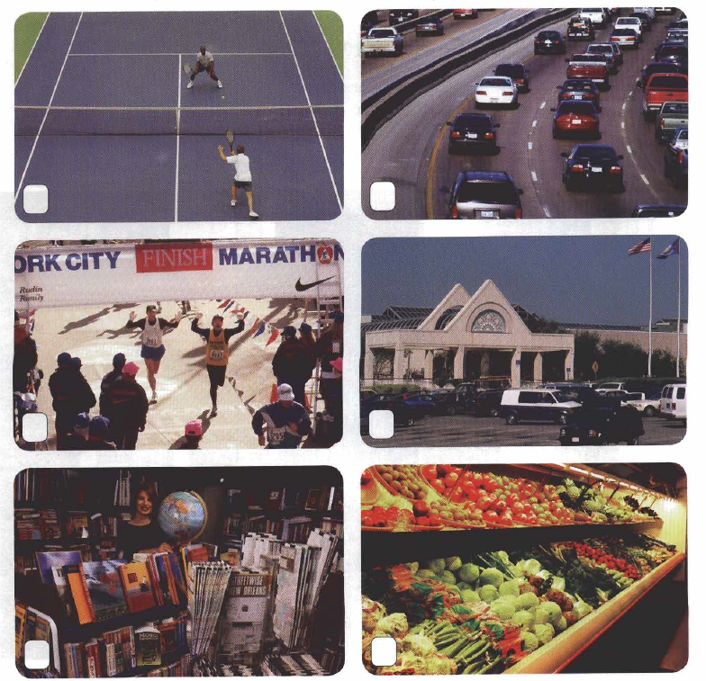

Task 3: Listen. People are talking about coming-of-age ceremonies.
When do the ceremonies happen? Circle the correct answers. Listen two times. (1.25pts)

1. a. at age 20 4. a. at high school graduation
b. at age 21 b. at college graduation
2. a. at age 15 5. a. the first year of high school
b. at age 16 b. the last year of high school
3. a. after marriage
b. before marriage

Task 4: Listen. People are describing the personalities of people they know.
What are the people’s relationships? Circle the correct answers. Listen two times. (1.25pts)
- a. sisters 4. a. college friends
b. mother and daughter b. father and son
2. a. co-workers 5. a. brothers
b. roommates b. classmates
3. a. husband and wife
b. neighbors

Task 5: Listen to people comparing two cities.
Circle the city each person prefers. Listen two times. (1pt)
- a. Washington, D.C 3. a. Singapore
b. New York b. Hong Kong
2. a. Los Angeles 4. a. Sydney
b. San Francisco b. Melbourne

-----------------------------------------------------------------------------------------------------------------------------------
Task 6: Listen and fill in the blanks. Listen three times. (3.75pts)
Everybody (1)..……………… more (2) ………………….. in Hawaii. For example, on Fridays, many businesses have “Aloha Fridays”. That (3)….………..….. you can come to (4) ……….……….. in casual (5) …………………...: flowered dresses for women, called muumuus, and for men, colorful, flowered shirts called aloha shirts. In the (6) …………………….., when it’s hot, where you can wear shorts to work, too – of course, nice-looking shorts. It’s easy to (7)……………………. when you feel relaxed and (8) ……….…………..
There’s a lot to do here in Hawaii; tourists definitely won’t get (9) ………………. Most people come here just to relax and get away from their (10) ………...………….. Hawaii has a lot of spas where you can go to get a (11)…………………….. And there are lots of beautiful places to go outside and get some (12) ………………….… Just being out in (13) ………………….. is relaxing. Sometimes you can smell (14) ………………….. flowers in the air – it’s almost like aromatherapy. Some places even sell herbal tea (15)………………. from Hawaiian flowers and plants. You should try some!
______Hết_______
GHI CHÚ: CÁN BỘ COI THI KHÔNG ĐƯỢC GIẢI THÍCH GÌ THÊM.

TRƯỞNG KHOA GIẢNG VIÊN RA ĐỀ

Trần Kim Thu Liễu Nguyễn Thị Bảo Trân

